Last Capture: **July 12, 2016**

Data captured manually from: <http://webservices.bowl.com/USBCFindA/Home/Center> using Fiddler to capture and save the JSON responses.

**Instructions:**

1. Start **Fiddler**
2. Filter only JSON responses
   1. Select the **Filters tab** on the right.
   2. Check **Use Filters**
   3. **Show only the following Hosts**: **webservices.bowl.com**
   4. Select **Show only JSON**

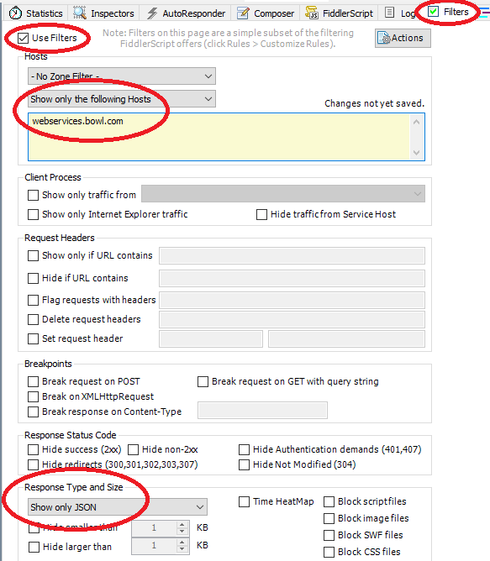

1. Navigate to: <http://webservices.bowl.com/USBCFindA/Home/Center>
2. **Remove** any Fiddler sessions
3. For each State:  
   1. Select the State in the combo
   2. Press **Search**
   3. Scroll down to the bottom of the page and click the next page link
   4. Repeat step 5a until all of the pages have been displayed, then click **New Search** to and then **Search** move onto the next state
4. Create a file system folder to hold the data files.
5. Select all of the Fiddler sessions (should be filter to be only JSON responses).
6. Select **File/Save/Response.Response Body…**
7. Navigate to your data folder and click **Save** to save each response.

Once you have all of the raw data files, you can use the following command to parse it:

**fun-tool parse-usbc-centers …**